Dealer Dash Board:
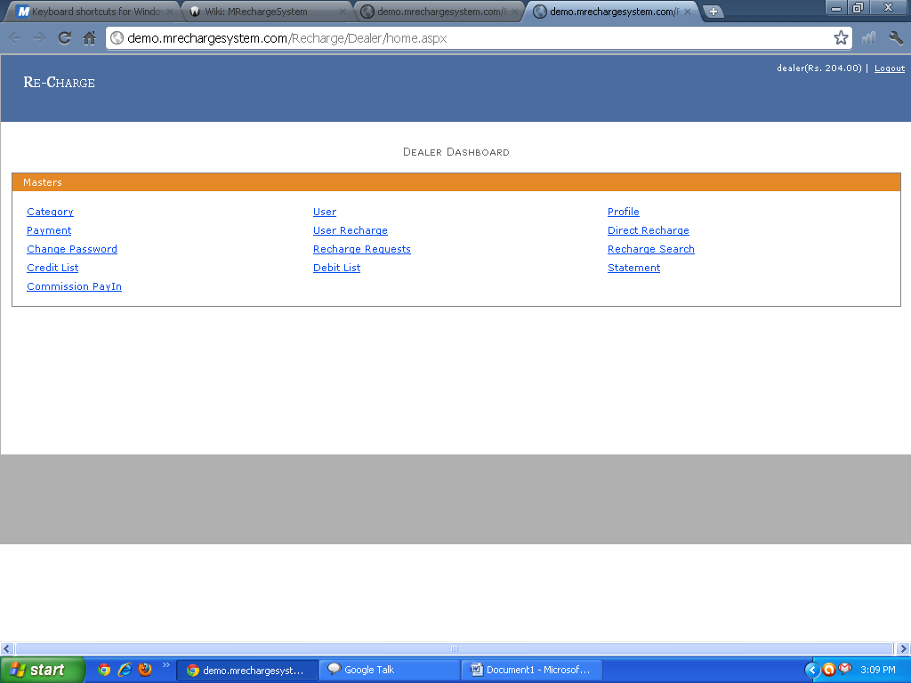
1) Category: Dealer can add the User or Dealer can also edit the information of the User and Dealer Can also Delete Particular User. 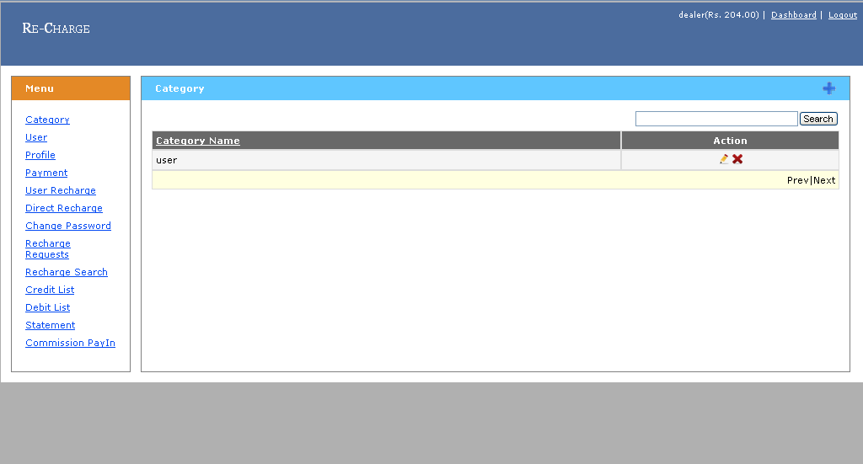

2) User Information: Dealer Can See All the Information Regarding User And Dealer Can Also Edit Delete And Crate User.
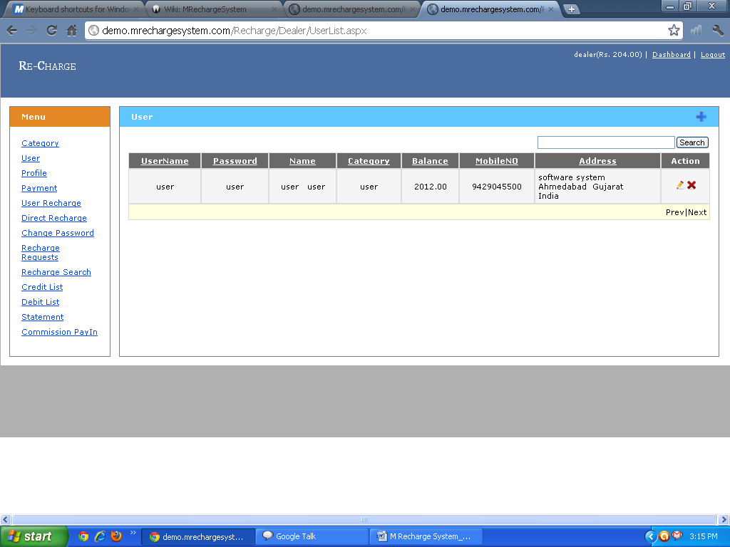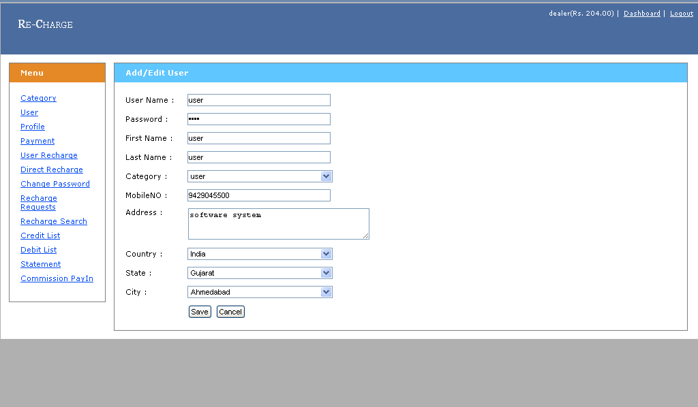

3) Dealer Profile: Dealer can see his Profile and Dealer can also Update Information.
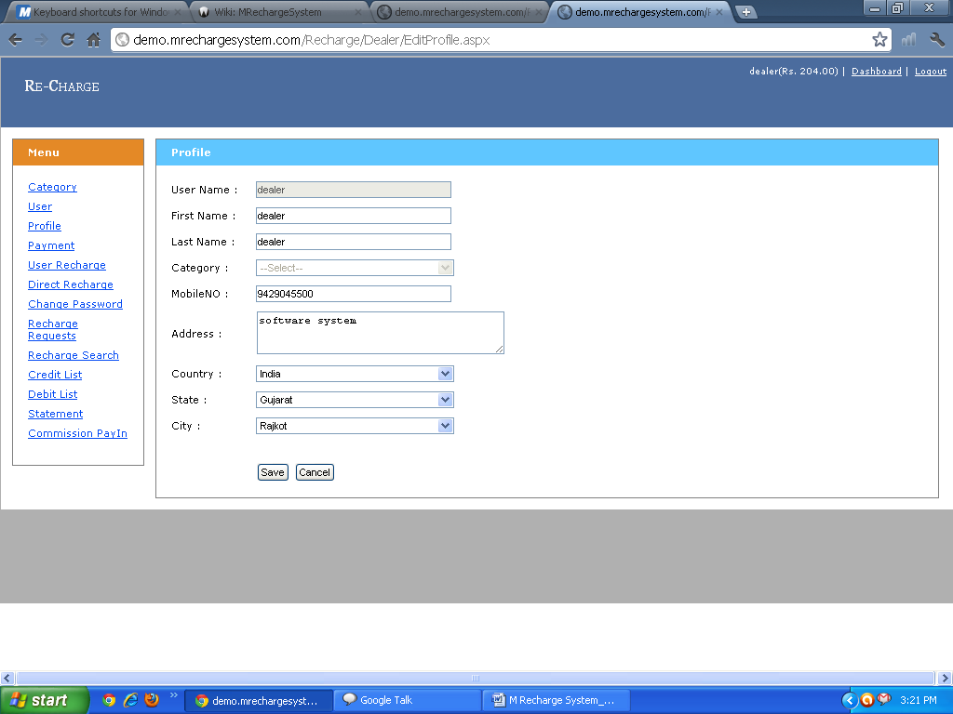
4) User Payment: Dealer can recharge the User Account and keep the information regarding User.

5) User Recharge: Dealer Can Direct Recharge Particular user Account Service. 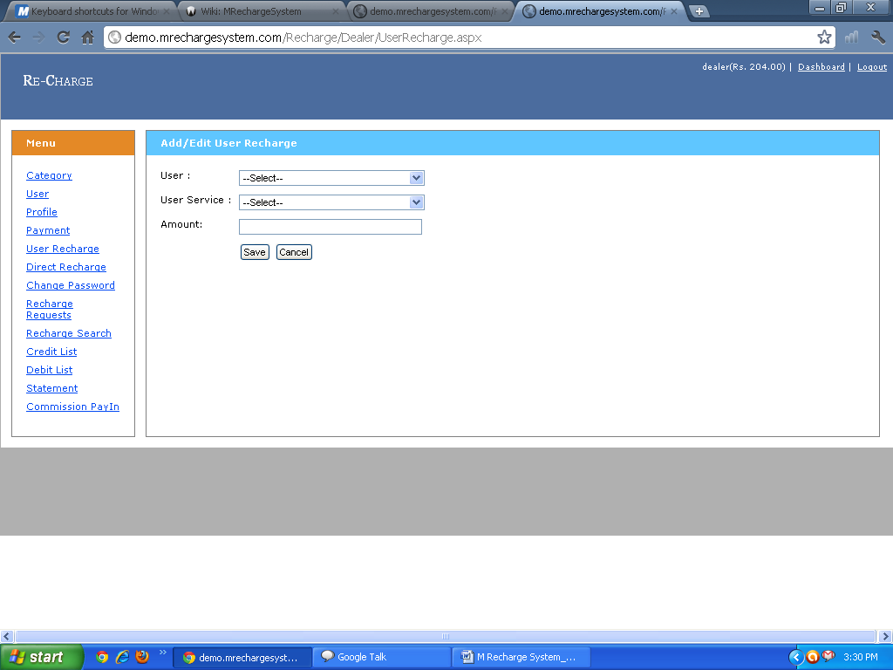
6) Direct Recharge: Dealer Can Direct Recharge On Particular Mobile Number.
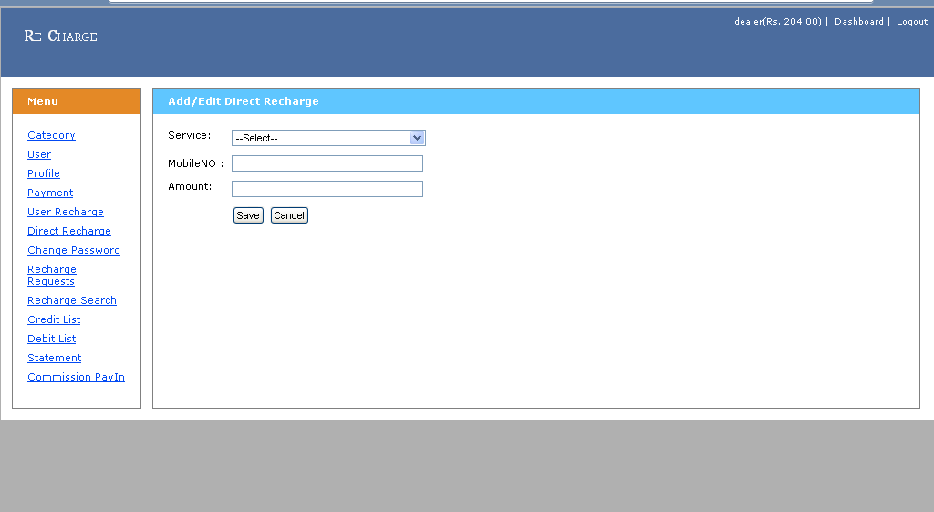

7) Change Password: Dealer can Change his Password Also.
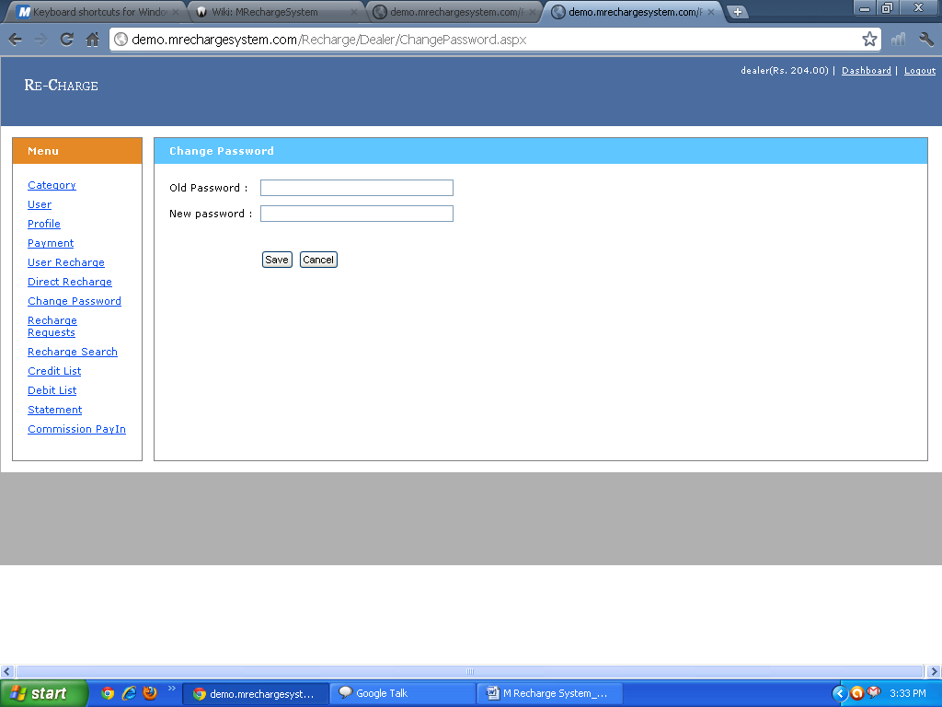
8) Recharge Request: Dealer can see how many user and Staff Member can Request for Recharge. Dealer Can See All the Information Regarding User and Staff. Dealer can find Particular User From Advance Search Option.
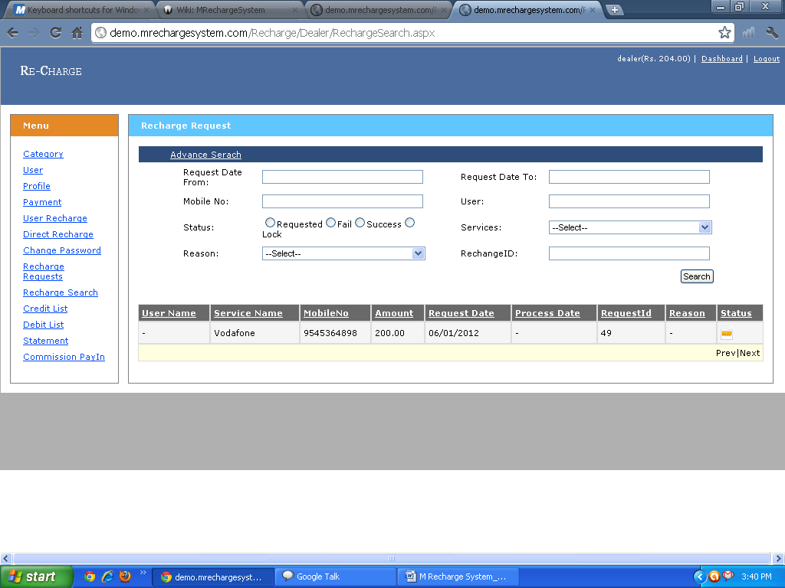

9) Credit List:Dealer can see the Credit List and see the Transaction Details and Status and used AdvanceSearch option for Finding particular infromation.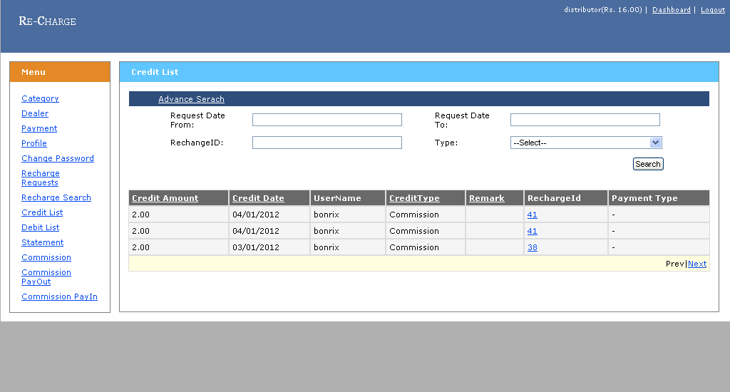
10) Debit List: Dealer can see the Debit List and see the Transaction Details and Admin can also used Advance Serch for finding particular user .
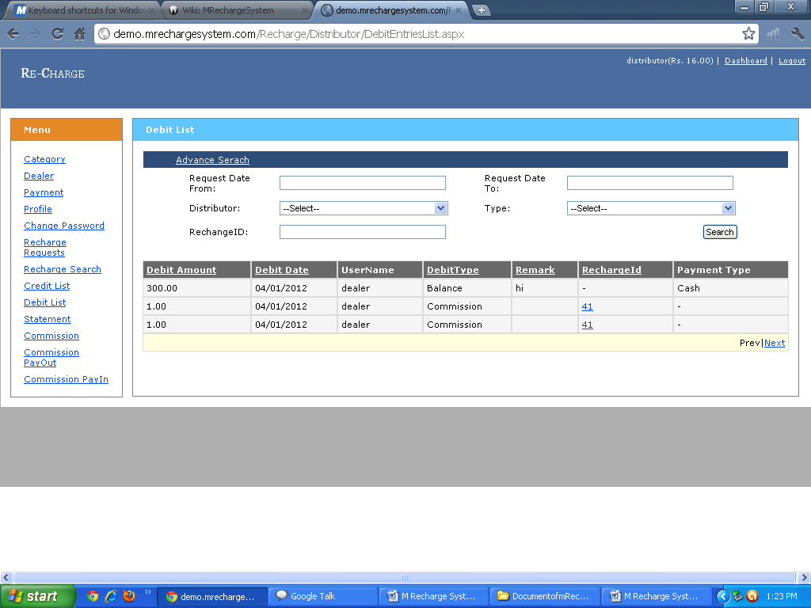

11)Statement: Dealer can See How many and Which Type of Transcation Perfrom By User.
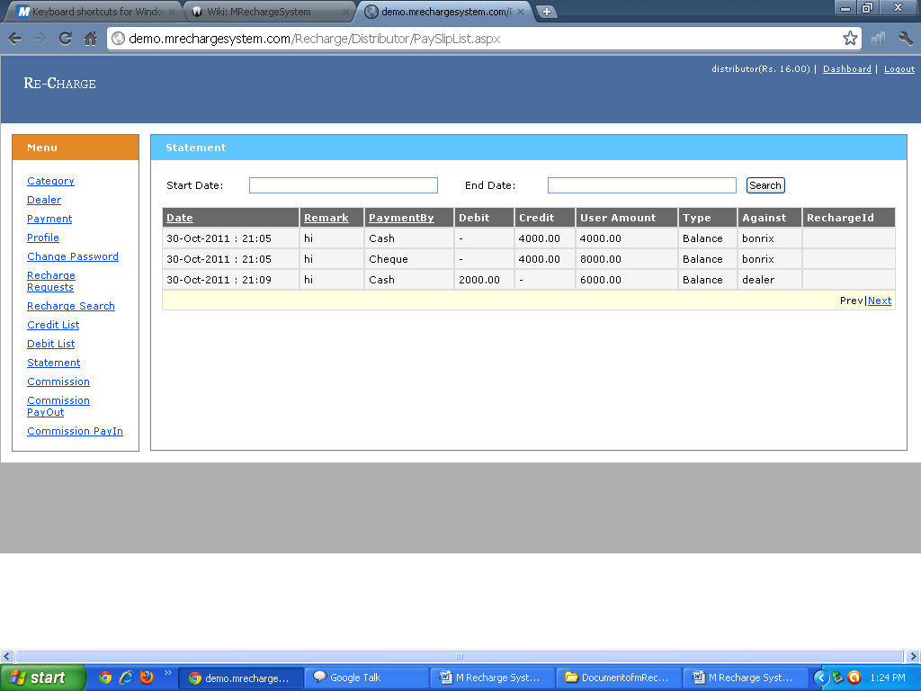
12) Commission Pay in: Dealer can see That Howmany Payment He Get Through Particular Services and also find the total Amount Of Service and Admin can also Advance search for finding Commission for Particular Service.
